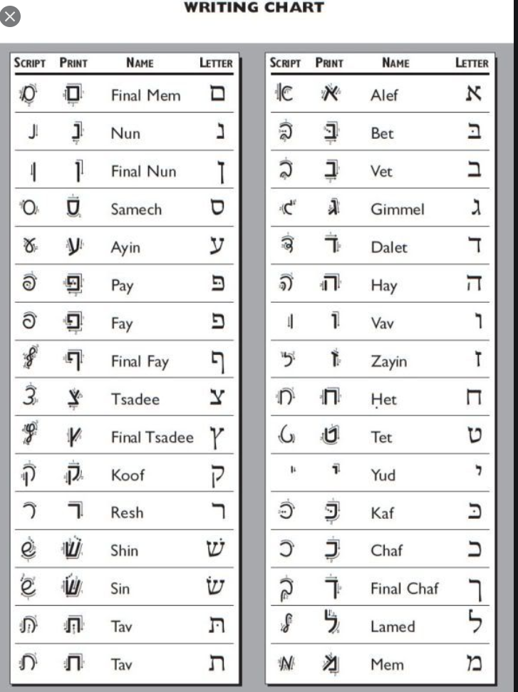

|  |  |
| --- | --- |
| א | a |
| ב | b |
| ג |  |
| ד | d |
| ה |  |
| ו |  |
| ז |  |
| ח |  |
| ט |  |
| י | J |
| כ | K |
| ל | L |
| מ | M |
| נ | N |
| ס |  |
| ע |  |
| פ |  |
| צ |  |
| ק | Q |
| ר | R |
| ש | S |
| ת | T |
|  |  |
|  |  |
|  |  |
|  |  |
|  |  |
|  |  |
|  |  |
|  |  |
|  |  |
|  |  |
|  |  |
|  |  |
|  |  |
|  |  |
|  |  |
|  |  |
|  |  |
|  |  |